NEWS FROM LA ESCUELITA – JUNE 2018

MEDICAL DELEGATION CANCELLED
Care Goes On But Food Insecurity Is Increasing

The Medical Delegation that was scheduled for April 30 – May 6 was canceled because of danger related to anti-government demonstrations. The peace of Nicaragua was disrupted by demonstrations which were met with a violent reaction by counter-demonstrators and police using live ammunition. Almost 75 people have been killed, transportation and work have been disrupted, stores have been looted and burned and families of the children in the school are unable to buy food. The cost of food is rising and the supply has dwindled.

Through the wonderful volunteer work of Dr. Lester Muñoz, the Nicaraguan doctor who helped last year, and the generous donation of $2000 from Evangelical Community Hospital of Lewisburg, PA, the children will all be examined and receive needed follow-up care over the course of several weeks.

HOWEVER, THE MOST IMMEDIATE NEED IS FOOD! Many parents have asked the teachers to help feed their families during this crisis. We hope that you will give generously to fulfill this need.

We are terribly saddened by the need to cancal the Medical Delegation, but even more saddened by the continuing events, hunger and violence in Nicaragua. Lives have been lost, property destroyed, and the country that has been known for years as the safest country in Central America has been wracked by the violence. And, as always in cases like this, the people who suffer the most are the poor and working people who didn't do anything to start the problem, but will pay a long-term price.

Please Give To Help La Escuelita Feed The Children And Their Families.
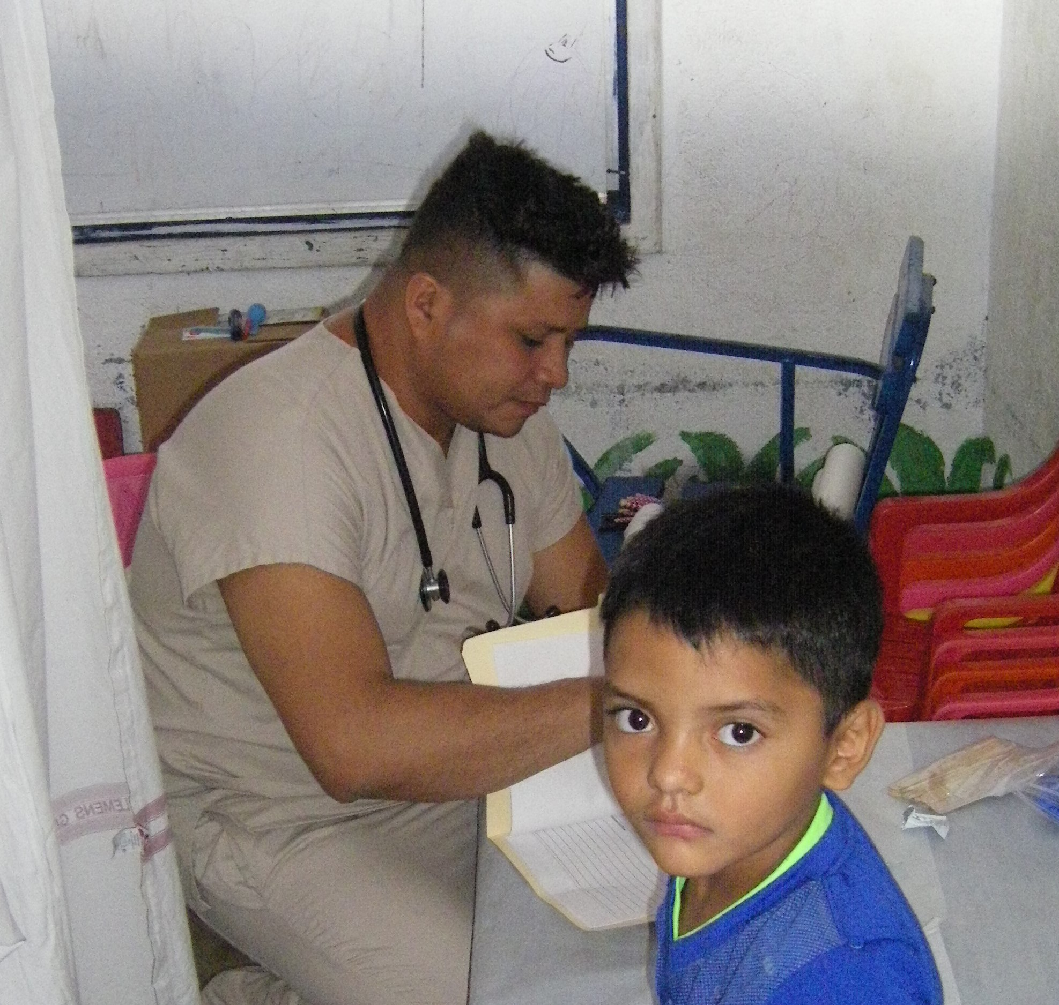 Dr. Muñoz with one of the children
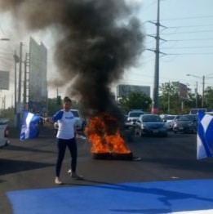People burned tires to block traffic
Make Checks to: CEPAD-USA, c/o Bev Kirkman, 5605 Groomsbridge Ct., Raleigh, NC 27612
With “Food program” in the memo line.

