Because Of Gifts From People Like
YOU
Wonderful Things Are Happening At
La Escuelita
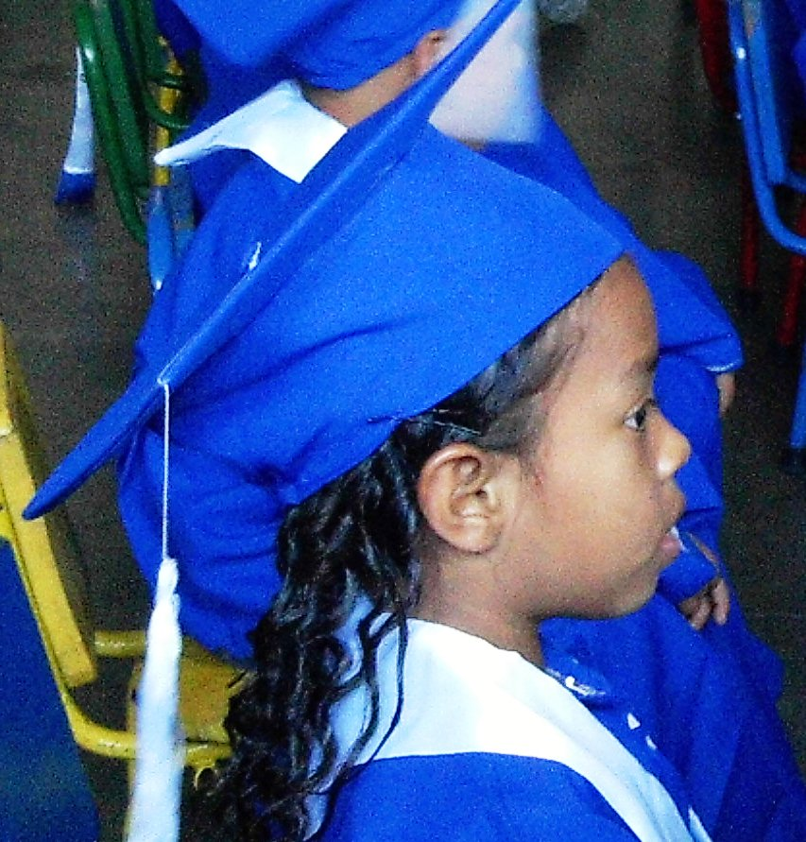

At the end of November more than 60 children will complete their pre-school time and be promoted into First Grade with a much stronger head start on their education.

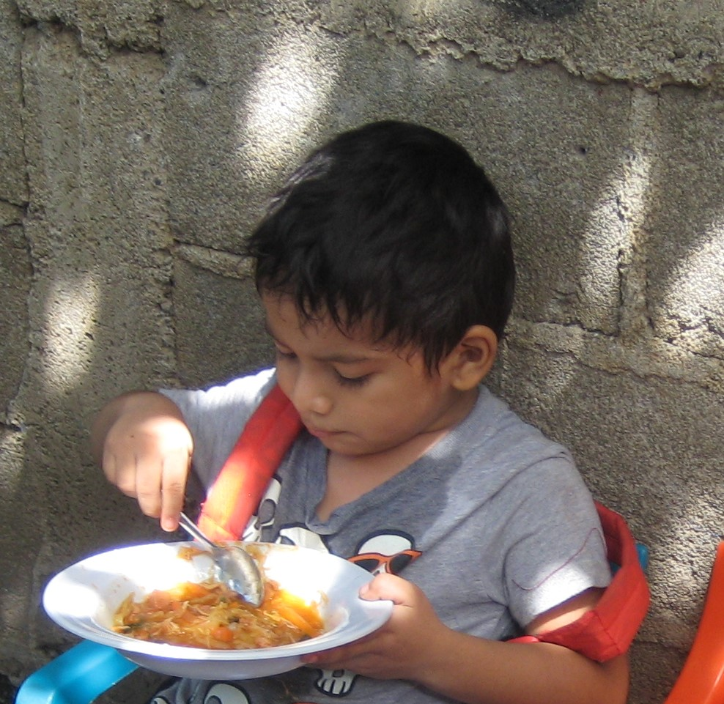

The food program, reader's program, health care and dental programs continue to provide needed services to these children. Ramon gets a warm lunch every day, which is often the only hot meal of the day for him.
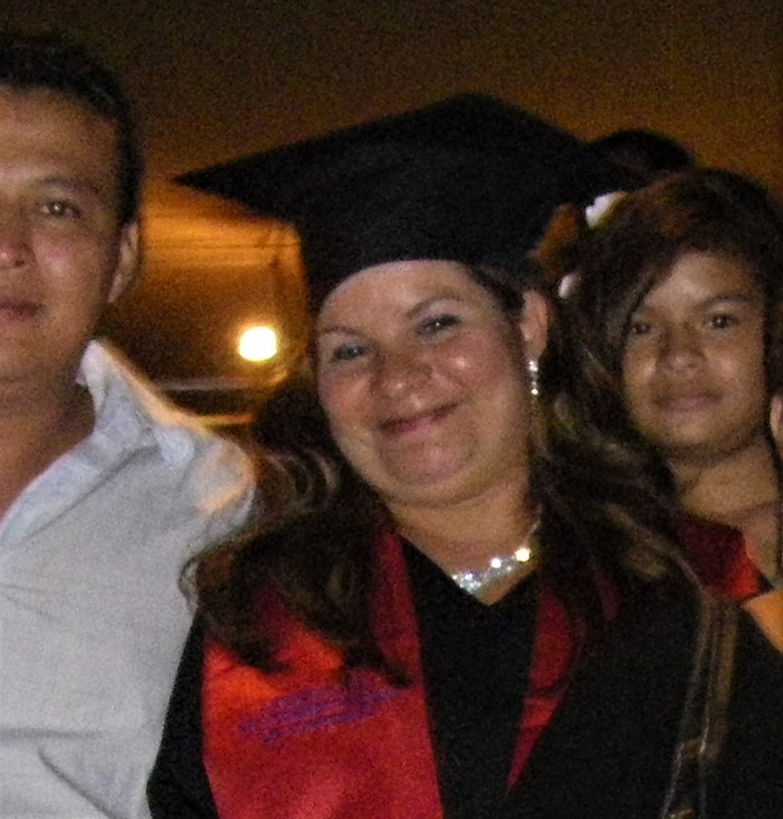

Many students continue their studies with help from the “Dreams to Reality” Scholarship Fund. Oneyda graduated from the university this year with a degree in Business Administration.

And With Your Help, We Can do Even More!
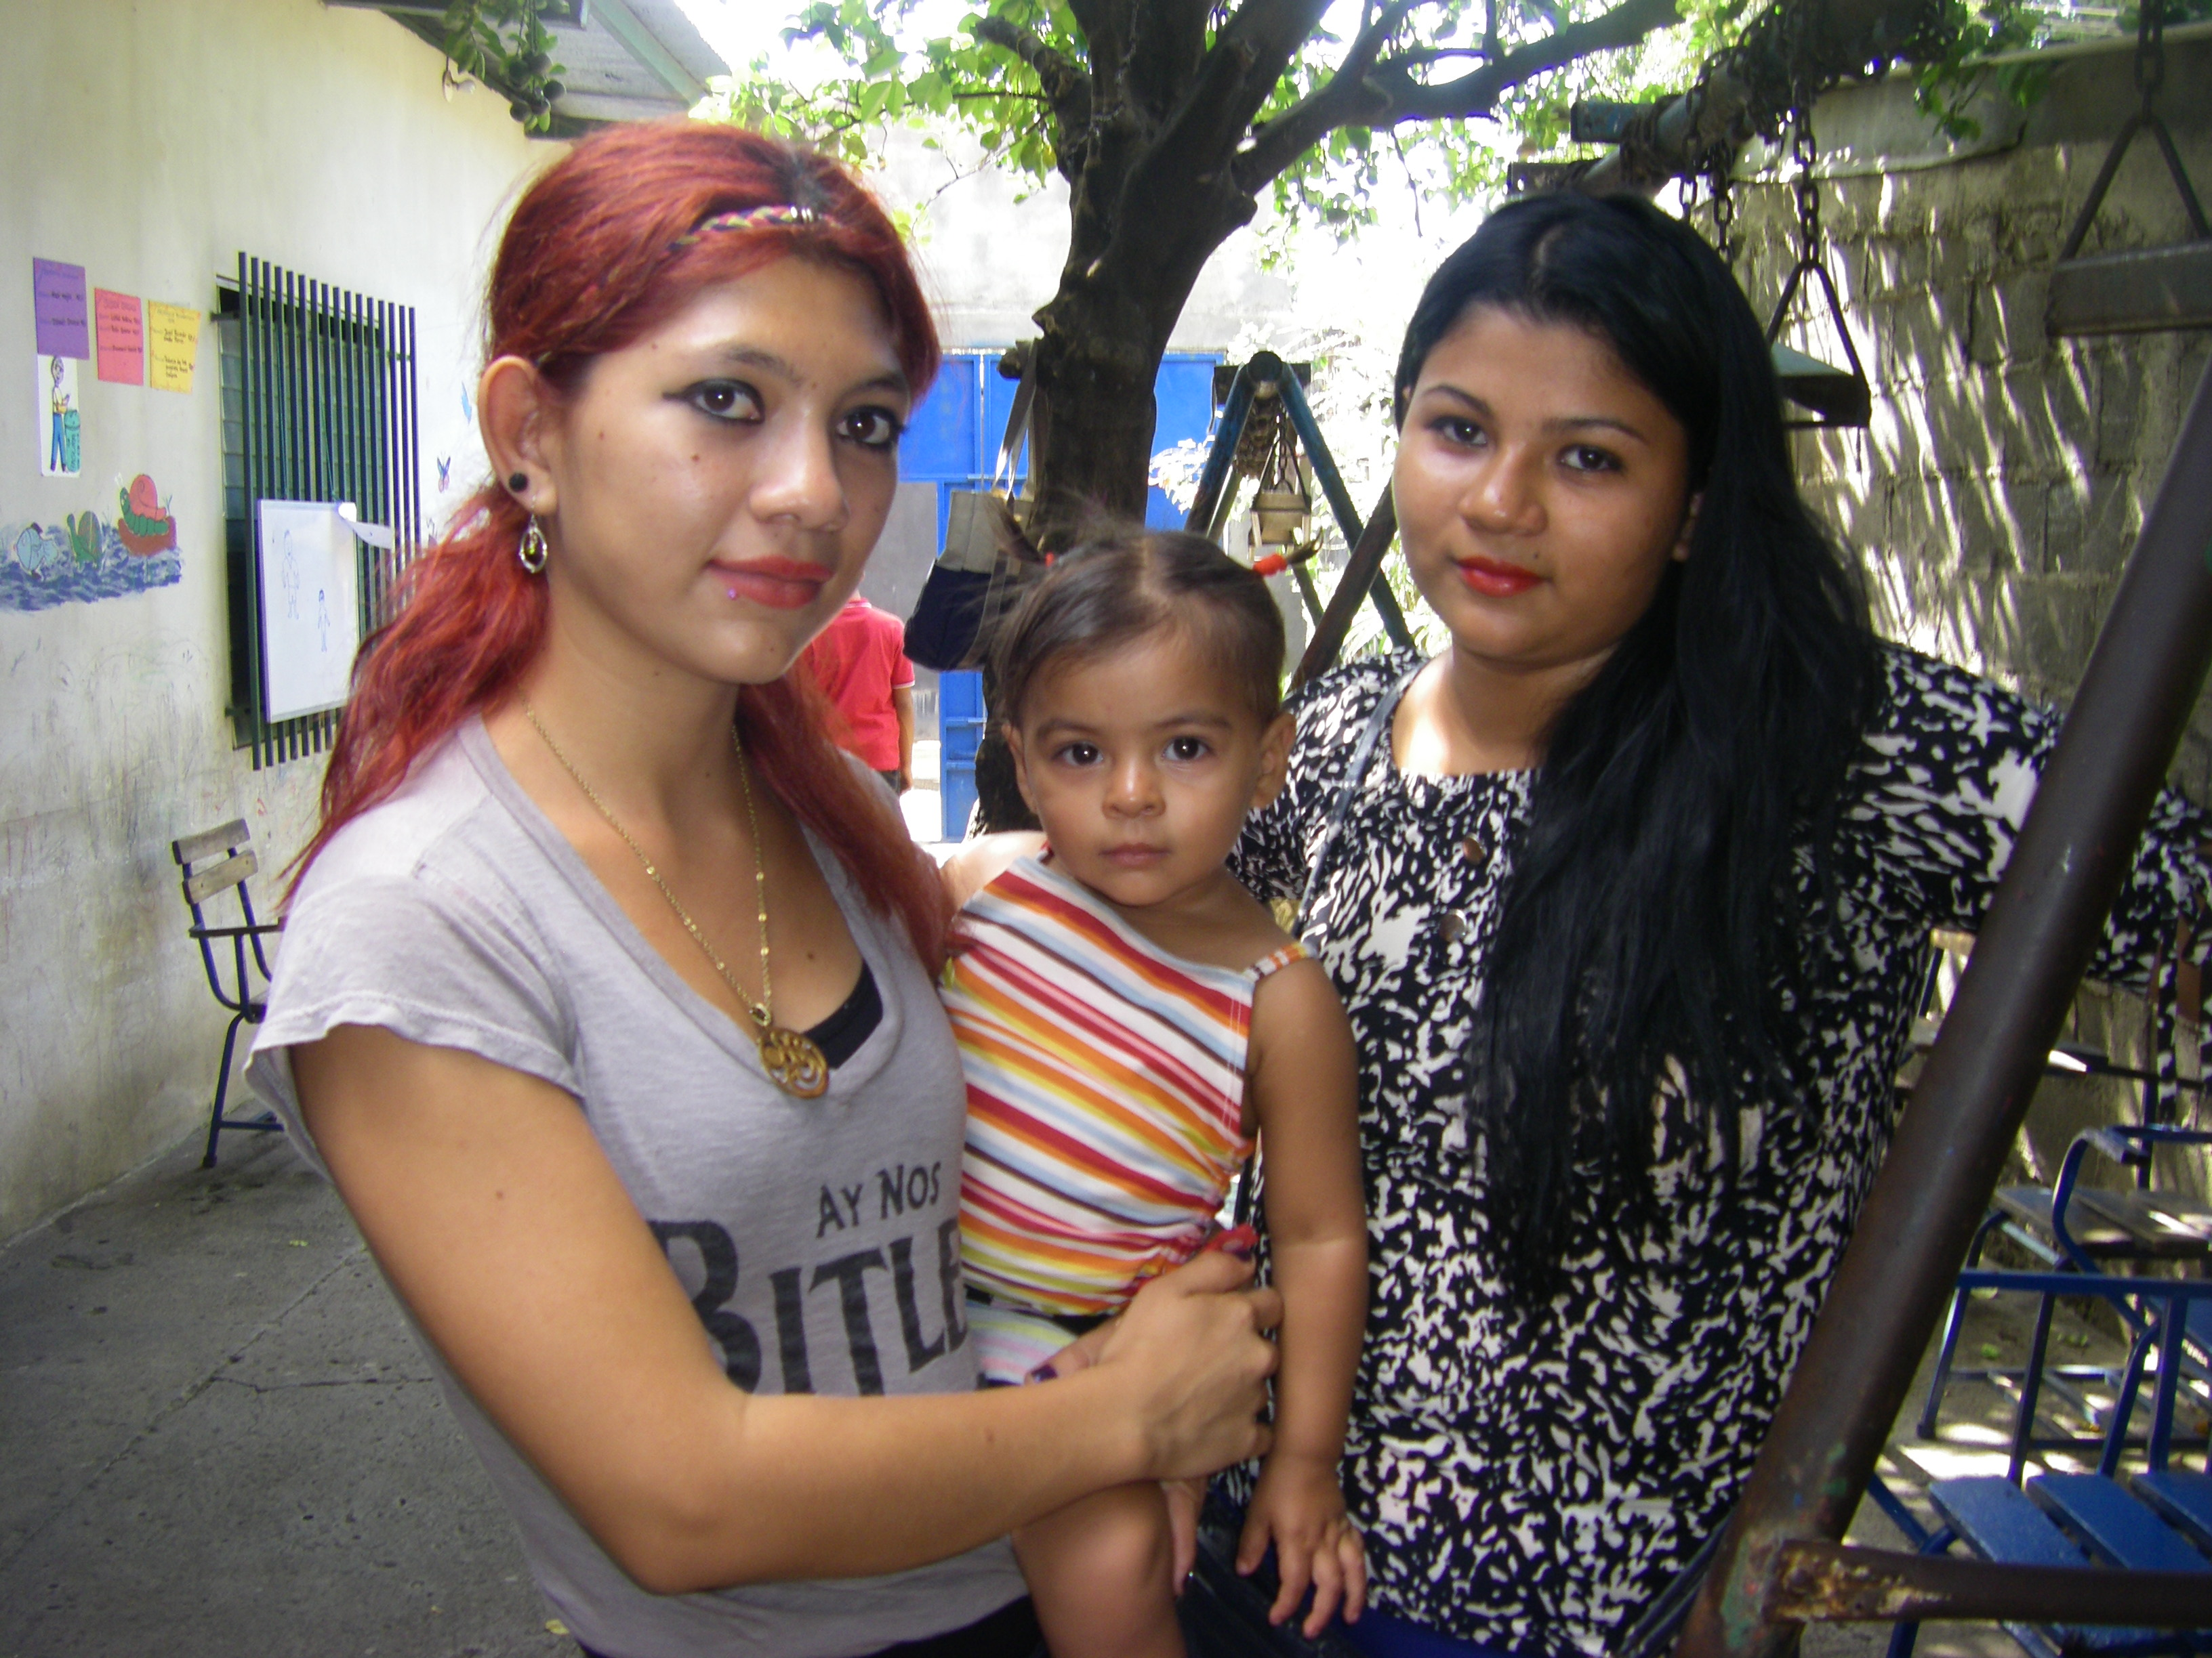
As with many former students,Virginia and Anna have stayed in contact with the teachers. Now, Virginia is ready to bring her daughter for pre-school.

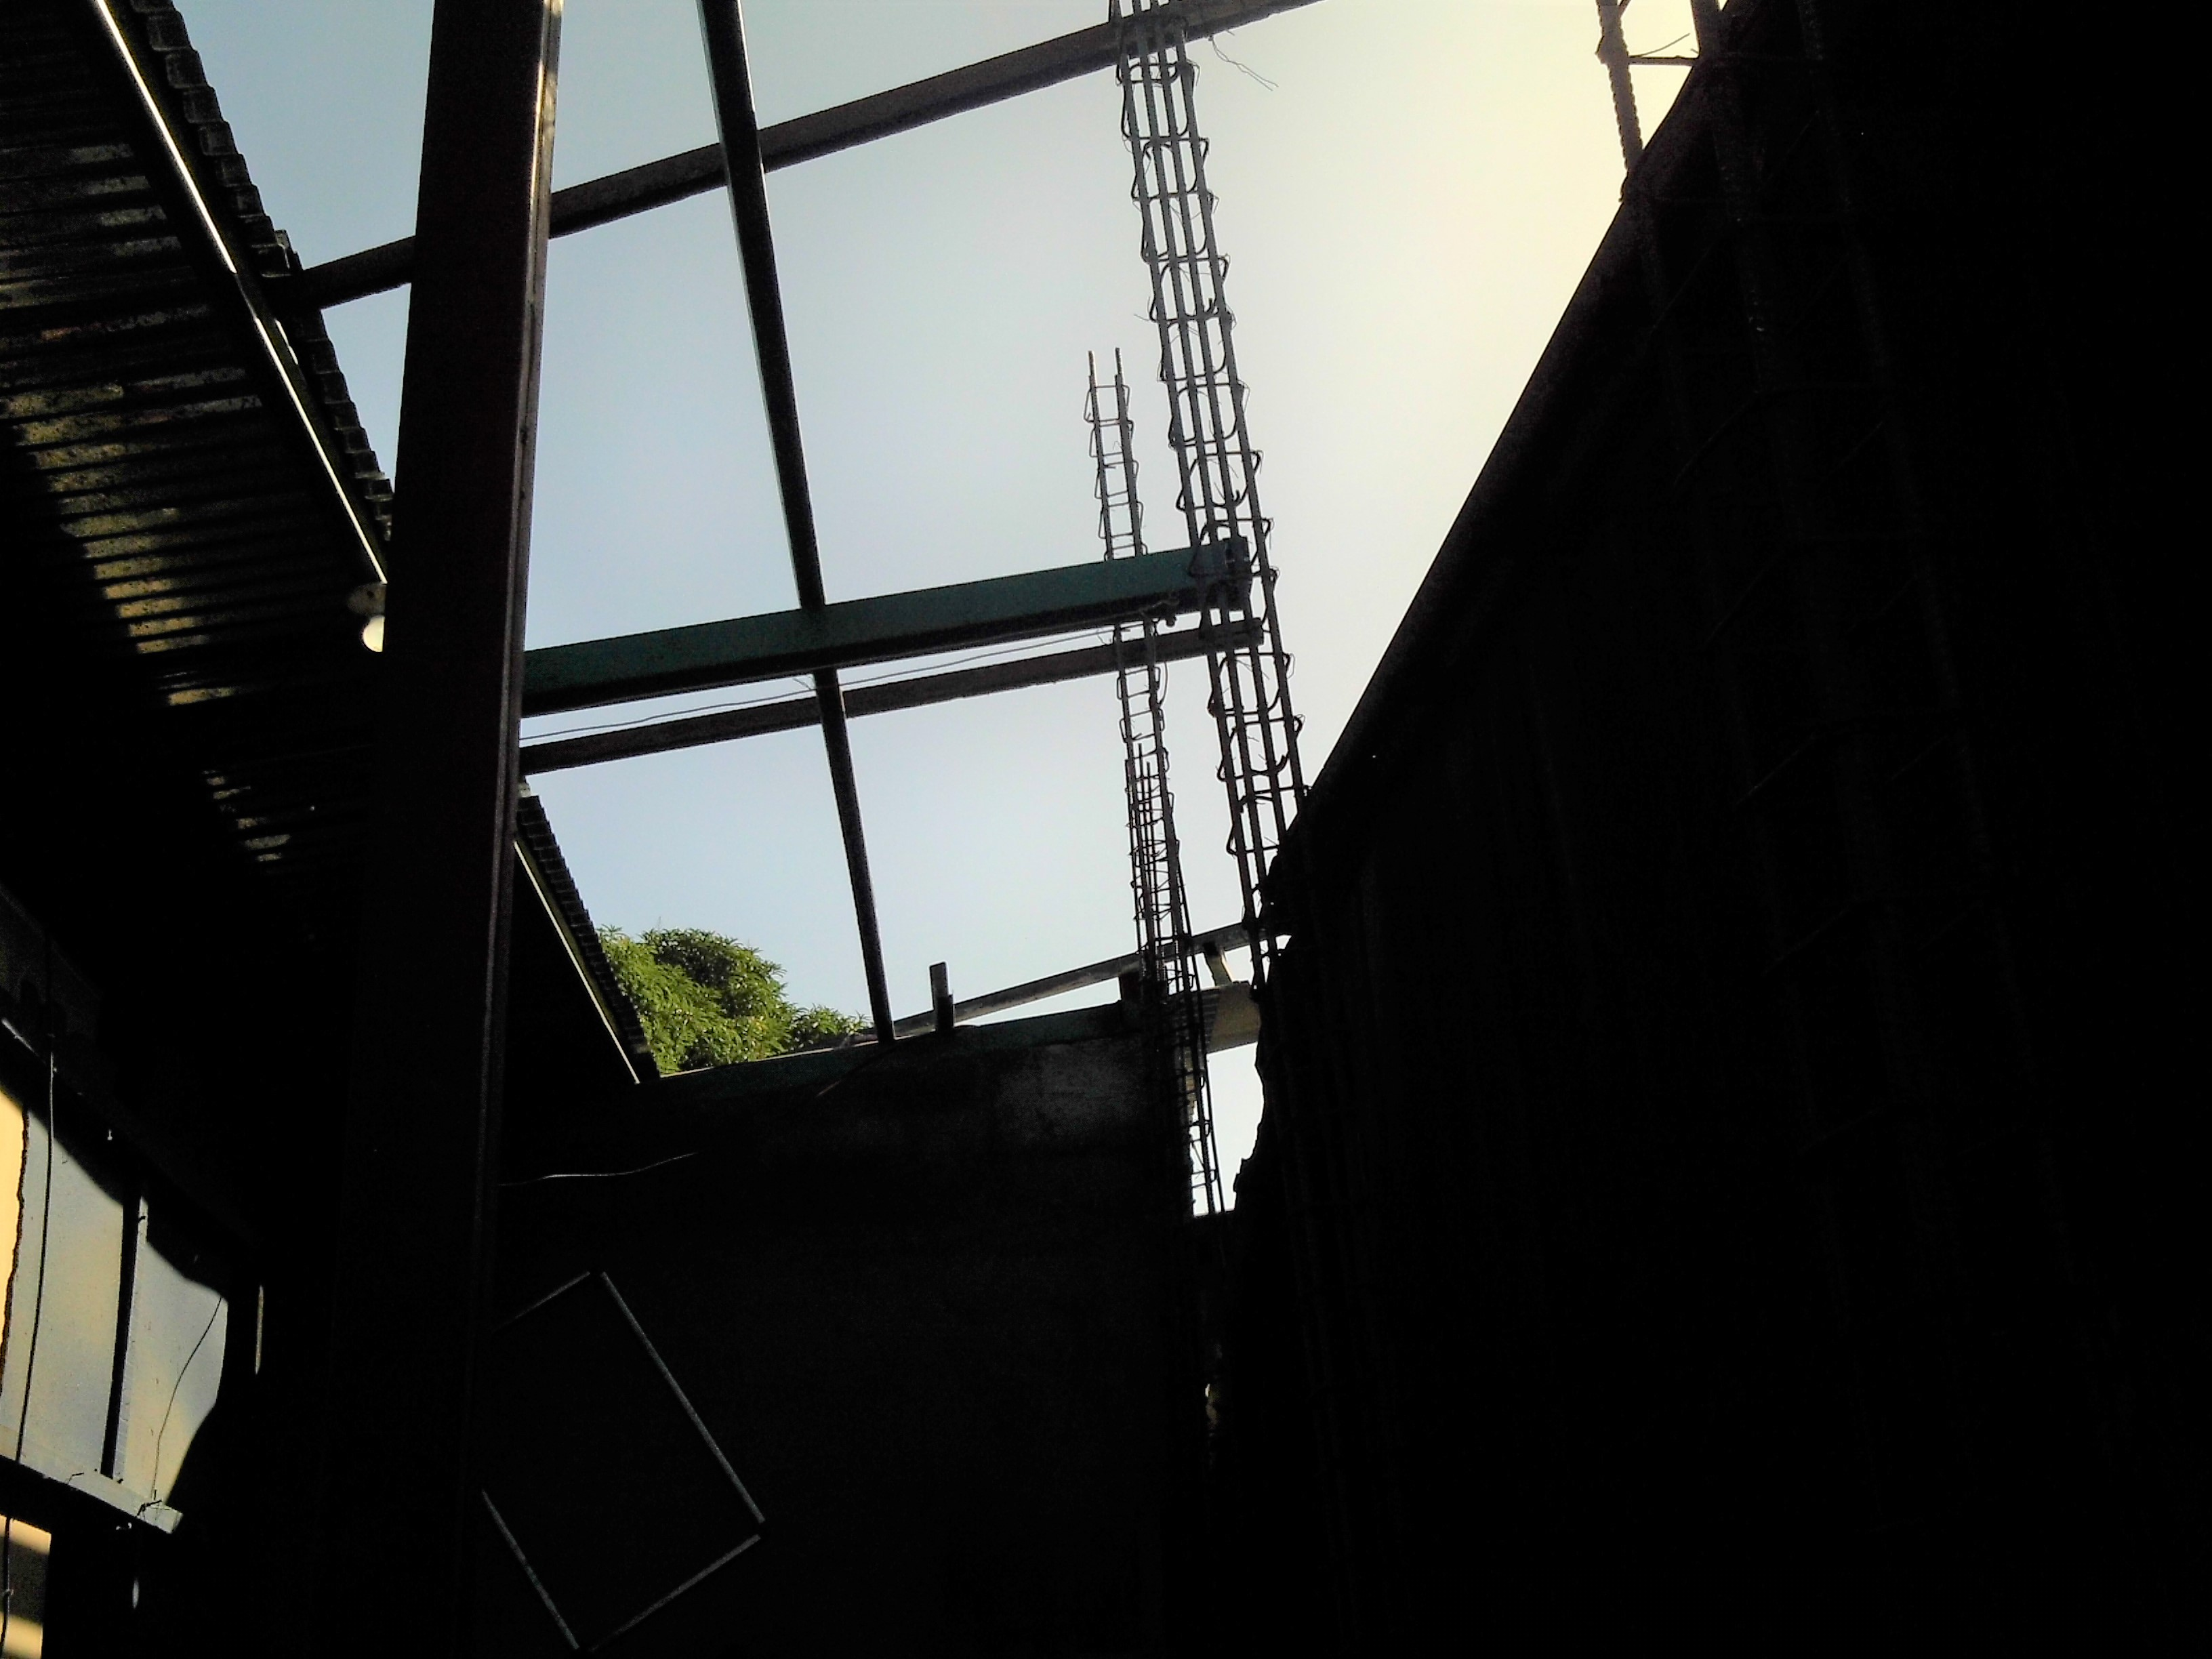

In early December, construction will begin on the second floor because of YOUR generous gifts.

All this is made possible by YOUR contributions, made out to CEPAD-USA and sent to:
CEPAD-USA
C/O Beverly Kirkman
5605 Groomsbridge Ct.
Raleigh, NC 27612
At La Escuelita a little bit goes a long way to help a lot of children.

DID YOU KNOW?
Internal Revenue Service regulations now allow for the Minimum Required Distribution from your IRA accounts to be sent directly as charitable contributions without passing through your hands, thus saving you on your taxes. Check with your Tax Accountant or investment advisers.

